
School: ............................................................................................................. Campus: ....................................................... Academic Year: ...................... Subject Name: ........................................................... Subject Code: ..........................
Semester: ............... Program: ........................................ Branch: ......................... Specialization: .......................... Date: .....................................
(Learning by Doing and Discovery)
* Coding Phase: Pseudo Code / Flow Chart / Algorithm
Deploying Your First Solidity Smart Contract on Remix IDE
1. Code Compilation
- Remix automatically turns your Solidity source code into bytecode and an ABI, no extra setup needed.
- This step ensures the contract syntax is valid and that you’re using a compatible compiler version.
- If there’s a syntax mistake or a wrong compiler version, deployment cannot proceed.
2. Deployment Setup
- MetaMask serves as the connector between Remix and your chosen Ethereum network (testnet or mainnet).
- On deployment, MetaMask will open a confirmation window showing:
  - The wallet address sending the contract
  - Estimated gas costs
  - The network you’re connected to
- This highlights that deploying isn’t just “saving” a file — it’s sending a blockchain transaction.
3. Transaction Execution
- You can monitor the transaction using its hash on a block explorer (e.g., Etherscan, Sepolia Explorer).
- Once mined, your contract receives a unique, permanent blockchain address.
- The gas fee is taken from your MetaMask account — even on testnets, these fees are simulated to mimic real costs.
4. Using the Deployed Contract
- Remix creates an interactive panel for running the contract’s functions.
- Any function that changes blockchain data will trigger another MetaMask confirmation.
- You can view data changes and emitted events directly from Remix’s interface.

Coding Phase: Pseudo Code / Flow Chart / Algorithm
Procedure for Writing Your First Solidity Contract (Using Remix) :
Step 1: Open Remix IDE
· Visit https://remix.ethereum.org
Step 2: Create a New File
· In the left sidebar, click on File Explorer → click the "contracts" folder.
· Click on the "+" icon to create a new file.
Step 3: Write the Smart Contract Code

pragma solidity ^0.8.0;
contract SimpleStorage{
uint public storedData;
constructor(uint data){
storedData = data;
}
function set(uint x)public {
storedData = x;
}
function get() public view returns (uint) {
return storedData;
}
}
Step 4: Compile the Contract
Step 5: Deploy the Contract
· Go to the Deploy & Run Transactions tab (icon: Ethereum with a play button).
· Environment: Select Injected Injected Provider MetaMask
· In the constructor input, add your message like "SimpleStorage"
· Click Deploy
Step 6: Interact with the Contract
After deployment:
· Under “Deployed Contracts
Use the buttons:
· getMessage(): reads the current message
· setMessage("New Message") → updates the message
· message() → public getter to see current message

* Softwares used
- Remix IDE
- MetaMask Wallet

- Testing Phase: Compilation of Code (error detection)
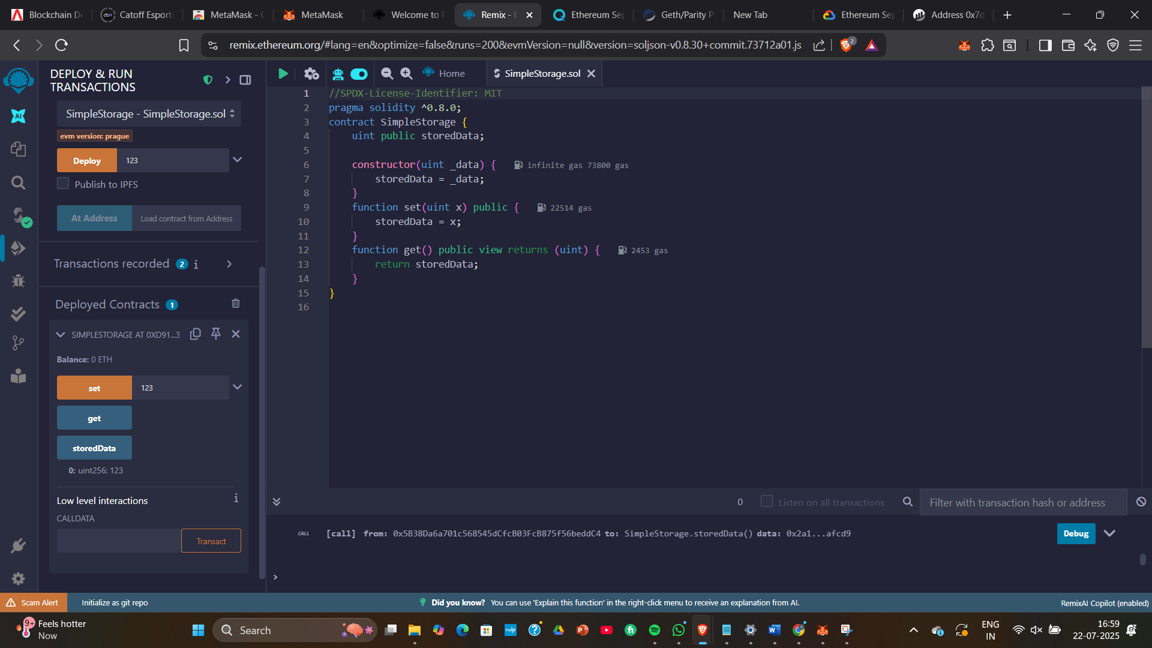

- Implementation Phase: Final Output (no error)

Implementation Phase: Final Output (no error)

- Implementation Phase: Final Output (no error)
Applied and Action Learning

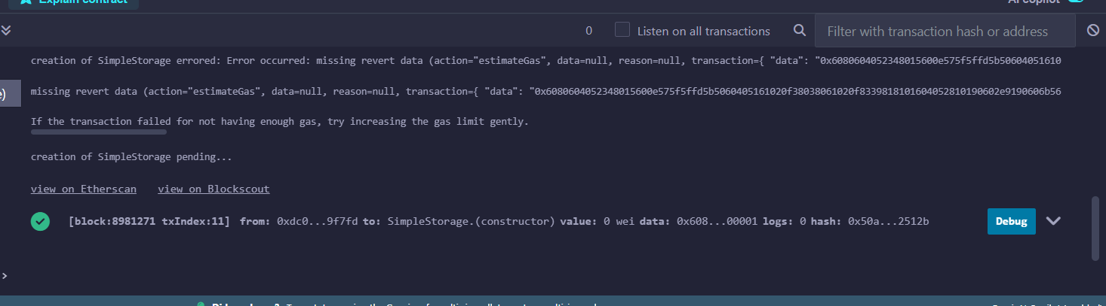

* Observations
- Once a smart contract is deployed, its code cannot be altered — any errors in logic mean creating and deploying a new version.
- The amount of gas consumed is influenced by how complex the constructor is and the amount of data written to storage.
- Even the most basic contract leaves an unchangeable record on the blockchain and requires gas to deploy.
- MetaMask functions not only as a wallet, but also as the tool that authorizes and sends transactions to the network.

ASSESMENT

Rubrics
Concept | 10
Planning and Execution/  Practical Simulation/ Programming | 10
Result and Interpretation | 10
Record of Applied and Action Learning | 10
Viva | 10
Total | 50


Signature of the Student:
Signature of the Faculty:

